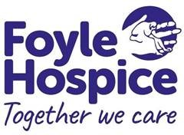
GIFT AID DECLARATION

Are you a UK Tax Payer?

If so, make your donation go further
Gift Aid is reclaimed by Foyle Hospice from the tax you pay for the current tax year. Your address is needed to identify you as a current UK taxpayer
by 25p for every £1 you donate

In order to Gift Aid your donation you must tick the box below:

I want to Gift Aid my donation of £______________ and any donations I make in the future or have made in the past 4 years to Foyle Hospice



“I am a UK taxpayer and understand that if I pay less Income Tax and/or Capital Gains Tax than the amount of Gift Aid claimed on all my donations in that tax year it is my responsibility to pay any difference”

Title First name Surname

Home Address ______________________________________________________

___________________________________________________________________

Postcode ____________________________ Phone Number

Email ______________________________________ Date ___________________

Please notify Foyle Hospice if you:
• want to cancel this declaration
• change your name or home address
• no longer pay sufficient tax on your income and/or capital gains

If you pay Income Tax at the higher or additional rate and want to receive the additional tax relief due to you, you must include all your Gift Aid donations on your Self-Assessment tax return or ask HM Revenue and Customs to adjust your tax code.

Please return completed declaration to:
Bernadette Wilkinson, Foyle Hospice, 61 Culmore Road, BT48 8JE.

Charity number XN/76407
Registered with the Charity Commission for Northern Ireland NIC 100871

